**ASSIGNMENT 2**

**AIM:**

To design LPF, HPF and BPF Circuits in NGSPICE.

**CIRCUIT:**

1. LPF:

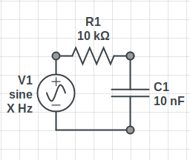

2. HPF:

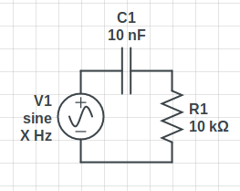

3. BPF:

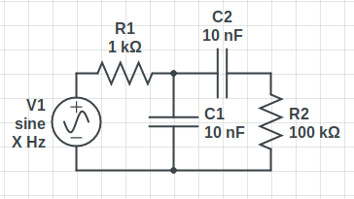

**OBSERVATIONS:**

1. Low Pass Filter AC analysis:

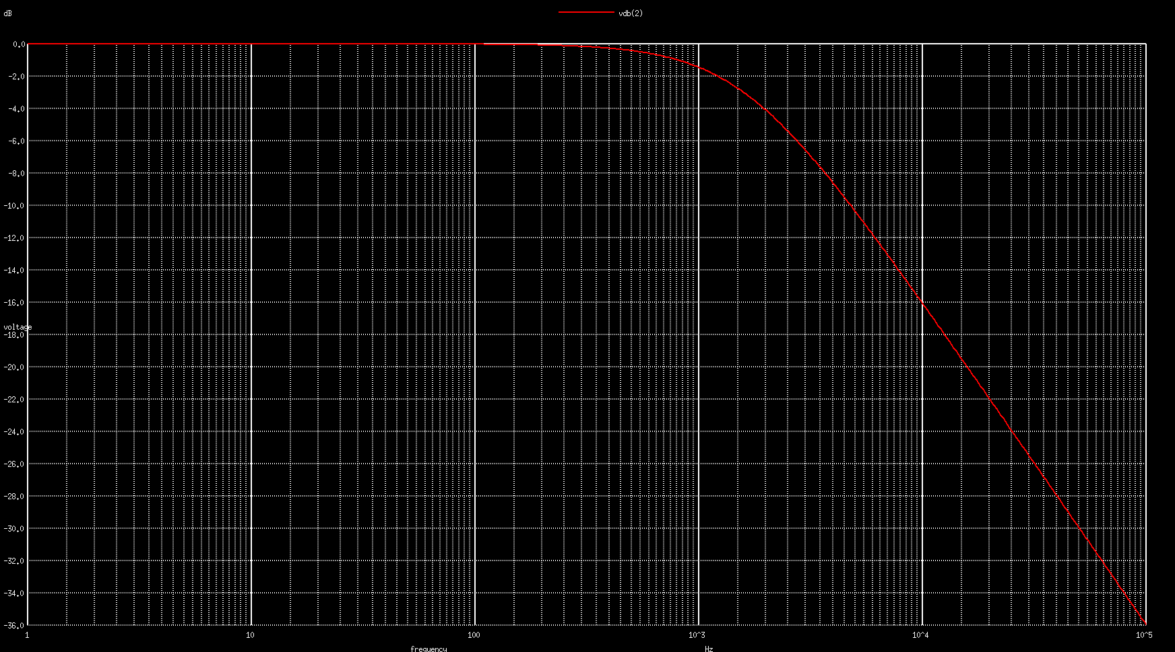

2. High Pass Filter AC analysis:

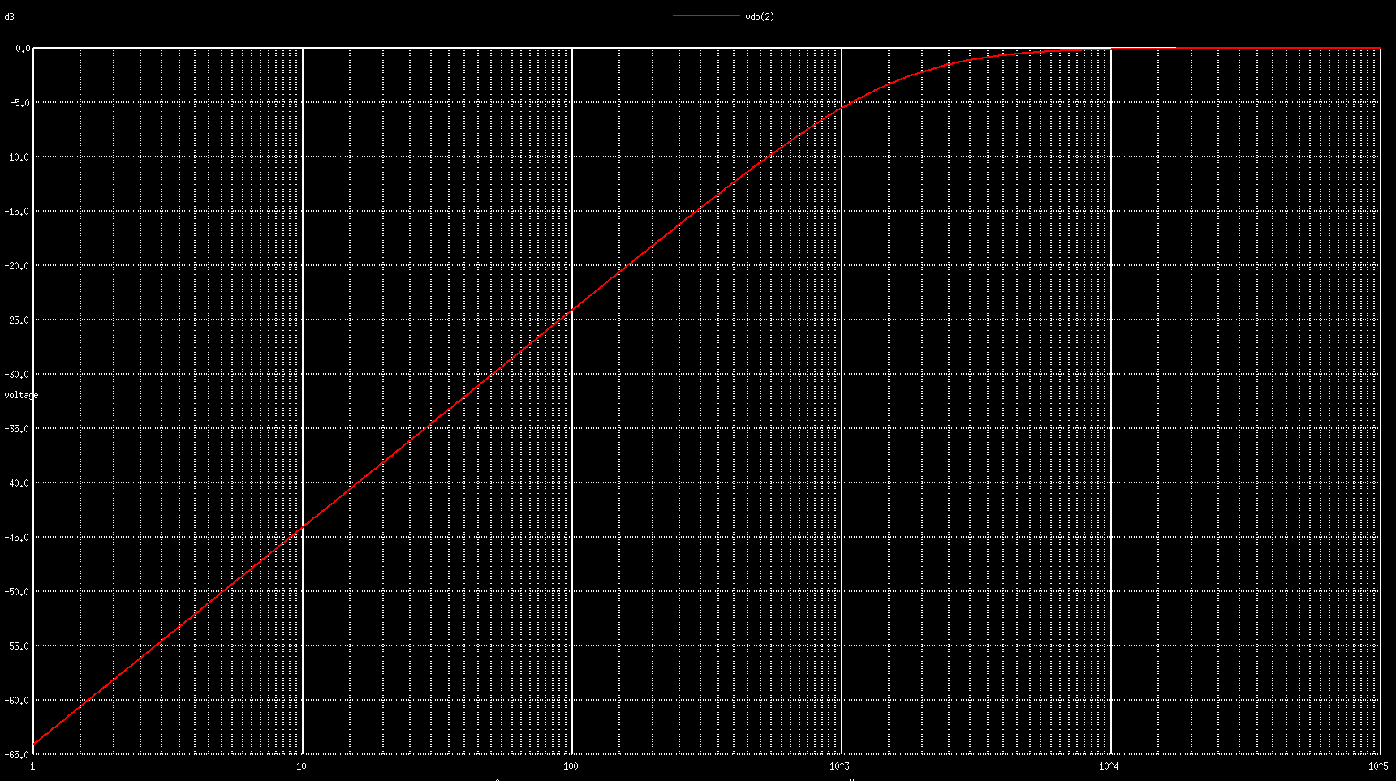

3. Band Pass Filter AC analysis:

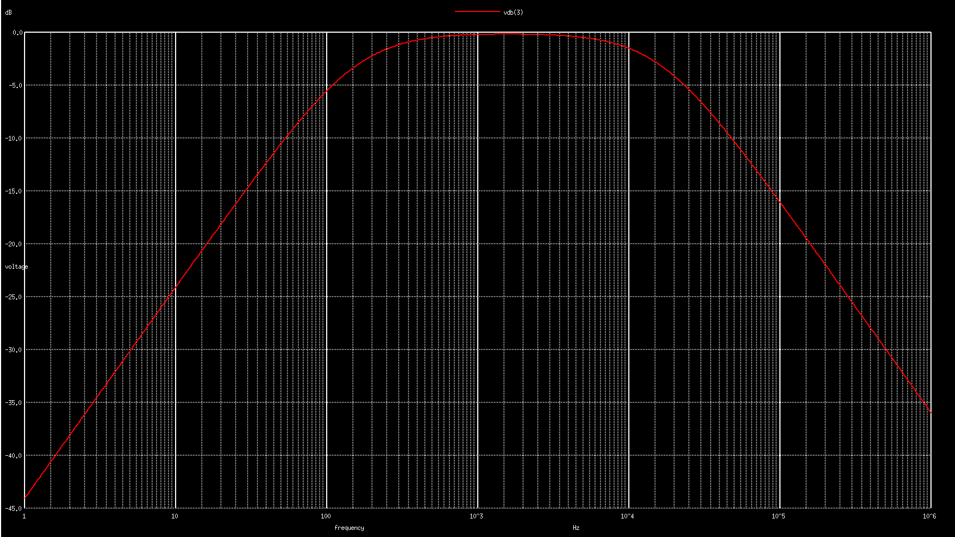

**CONCLUSION/RESULT:**

1. The LPF cut off is kept at ~1.6 KHz using an RC circuit with R1=10k and C1=10n.

2. The HPF cut off is kept at ~1.6 KHz using an RC circuit with R1=10k and C1=10n.

3. The BPF cut off is kept at ~160 Hz - ~160 Khz using two RC circuits(an LPF and an HPF) using R1=1k, C1=10n and R2=100k, C2=10n